

Darshan University

A Project Report on

**Collage Management System**

Under the subject

**Software Engineering (2301CS405)**

B. Tech, Semester – IV

Computer Science & Engineering Department

|  |  |
| --- | --- |
| Submitted By | |
| Student Name:Ghada Afsana R. | Enrollment No.:24010101633 |
| Academic Year  (2024-2025) | |
| Internal Guide Prof. R. B. Gondaliya  Darshan University | Dean-DIET Dr. Gopi Sanghani  Darshan University |

|  |  |
| --- | --- |
|  | **Computer Science & Engineering Department**  **Darshan University** |

# DECLARATION

We hereby declare that the SRS, submitted along with the **Software Engineering (2301CS405)** for entitled **“Collage Management System”** submitted in partial fulfilment for the Semester-4 of **Bachelor Technology (B. Tech)** in **Computer Science and Engineering (CSE)** Department to Darshan University, Rajkot, is a record of the work carried out at **Darshan University, Rajkot** under the supervision of R. B. Gondaliya and that no part of any of report has been directly copied from any students’ reports, without providing due reference.

(Ghada Afsana)

Student’s Signature

Date:

|  |  |
| --- | --- |
|  | **Computer Science & Engineering Department**  **Darshan University** |

# CERTIFICATE

This is to certify that the SRS on **“Collage Management System” has** been satisfactorily prepared by **Ghada Afsana** (**24010101633**) under my guidance in the fulfillment of the course **Software Engineering (2301CS405)** work during the academic year 2024-2025.

|  |  |
| --- | --- |
| Internal Guide  Prof. R. B. Gondaliya Darshan University | Dean-DIET  Dr. Gopi Sanghani Darshan University |

# ACKNOWLEDGEMENT

I wish to express my sincere gratitude to my project guide Prof. R. B. Gondaliya and all the faculty members for helping me through my project by giving me the necessary suggestions and advices along with their valuable co-ordination in completing this work.

I also thank my parents, friends and all the members of the family for their precious support and encouragement which they had provided in completion of my work. In addition to that, I would also like to mention the Darshan University personals who gave me the permission to use and experience the valuable resources required for the project from the University premises.

Thus, in conclusion to the above said, I once again thank the faculties and members of

**Darshan University** for their valuable support in completion of the project.

Thanking You

**Ghada Afsana**

# ABSTRACT

Collage management system is a system which aims in developing a computerized system to maintain all the daily work of Collage. This system will act as a tool to transfer traditional Collage into digital Collage. This project has many features which are generally not available in general Collage system like facility of user login, Student search on one click etc. It also has a facility of admin login through which the admin can monitor the whole system. This system will be designed with the basic features such as Admin can add/view/update/delete Faculties and students' details in it.The Collage Management System is an integrated computerized system designed to manage and automate the daily administrative and academic tasks within a college. It aims to replace traditional paper-based processes with a digital solution, improving the efficiency and accessibility of various operations. The system incorporates features such as user and admin logins, book search, and easy management of student and book records.

Main purpose of this system is to reduce human efforts as much as possible.

**Table of Contents**

List of Figures I

List of Tables II

1. Introduction 1
   1. Product perspective 1
   2. Product features 1
      1. There are five different users who will be using this product: 1
      2. The features that are required for the admin are 1
      3. The features that are required for the student are 1
   3. Functional Requirement 1
      1. Admin 1
      2. Faculties 2
      3. Student 2
      4. Parents 2
      5. Mentor 2
   4. Non-Functional Requirement 2
      1. Usability 2
      2. Accuracy 2
      3. Availability 2
      4. Maintainability 2
      5. Reliability 2
      6. Security 2
      7. Efficiency 2
2. Design and Implementation Constraints 3
   1. Use case diagram 3
   2. Activity diagram and Swimlane diagram 4
   3. Sequence diagram 5
   4. State diagram 6
   5. Class diagram 7
   6. Data flow diagram 8
      1. Context diagram (level-0) 8
      2. DFD Level-1 8
      3. DFD Level-2 9
3. External interface requirement (Screens) 10
   1. Screen-1: Registration Form 10
   2. Screen-2: Login Form 11
   3. Screen-3: Add borrower book 12
4. Database design 13
   1. List of Tables 13
5. Stories and Scenario 14
   1. Story-1: Add New Book in Library Catalogue 14
      1. Scenario# S1.1 14
      2. Scenario# S1.2 14
      3. Scenario# S1.3 14
   2. Story-2: Search Book 15
   3. Story-3: Manage due date for borrowed book 15
   4. Story-4: Renew book 15
   5. Story-5: Generate a report on book usage and availability 15
6. Test cases 16
7. References 20

# List of Figures

Figure 2.1-1 Use case diagram for Collage management system 3

Figure 2.2-1 Activity diagram 4

Figure 2.2-2 Swimlane diagram 4

Figure 2.3-1 Sequence diagram 5

Figure 2.4-1 State diagram 6

Figure 2.4-2 State diagram 6

Figure 2.5-1 Class diagram for Collage management system 7

Figure 2.6-1 Context diagram for Collage management system 8

Figure 2.6-2 DFD level-1 for Collage management system 8

Figure 2.6-3 DFD level-2 9

Figure 3.1-1 Screen-1: Registration Form 10

Figure 3.2-1 Screen-2: Login Form 11

Figure 3.3-1 Screen-3: Add borrower book 12

# List of Tables

Table 3.1-1 Screen element of Registration form 10

Table 3.2-1 Screen element of Login form 11

Table 3.3-1 Screen element of Add borrower book 12

Table 4.1-1 Table: Faculties 13

Table 4.1-2 Table: Branch 13

Table 4.1-3 Table: Staff 13

Table 4.1-4 Table: Student 13

# Introduction

## Product perspective

The **Collage Management System** (CMS) provides an efficient way to manage the day-to-day activities of a college, including student records, book inventories, and administrative tasks. It offers distinct access rights for different users such as students, librarians, and admins to streamline their respective activities.

## Product features

### There are Five different users who will be using this product:

* Admin who will be acting as the administrator.
* Student who will be accessing the Application.
* .Faculties who will Upload

### The features that are required for the Admin are:

• Login to the admin panel with username and password.

• Generate various reports (student, book, teacher, issue report).

• Monitor and manage user accounts (students and librarians)Can issue a book to the student.

* Can view the data of student.
* Can update data for old student
* Can Information about Department & library
* Can Add Faculties
* Can Remove Faculties
* Can Generate a Fee Receipts
* Can generate Mark sheet for students
* Can access all the accounts of the students.

### The features that are required for the Member are:

* Can view the different categories of books available in the library.
* Can view the List of books available in each category.
* Can own an account in the library.
* Can view the books issued to him.
* Can put a request for a new book.

## Functional Requirement

### Admin

* Store New Student Data: can store data of new student.
* Update Data For Old Student : can update data of old student.
* Check The Student Remaining On It .
* Add Faculties : can add new faculties.
* Remove Faculties : can remove faculties.
* Add Branch : Add new branch in university.
* Remove Branch :admin can some reasons remove branch .
* Manage Registration : manage a full registration .
* Information about Department & library : information about department and library .
* Generate a Fee Receipts : generate a fee receipt for paid fee by student.
* Generate Mark sheet : generate mark sheet for exams.
* Pay Fee For Staff : pay fee to staff member.
* Verify Fee pay by Student

.

### Faculties

* Login Application : Login to the Faculties panel with username and password.
* Fill Attendances : Fill Attendances to who are present todays.
* Upload Material : Upload Material in application for student.
* Delete Materiel : Faculties can delete material.
* View Notices : view notices for new event or etc.
* Show Timetable : show timetable as per day.
* Update Timetable: update timetable for some cancel lectures.
* Information About Labs : information about student lab performance.
* Evaluate Student : evaluation of student.
* Check Student Data : check student data
  + 1. Student
* Sign in : student can sign in application.
* Download Materiel : download material for faculties can forward.
* Upload A Assignment : upload assignment as under time limit
* View Result : view result for given exams.
* View Attendance : view attendance.
* Edit Personal Info : edit personal information like photo.
* Give Feedback: given feedback for faculties.
* Update Profile:update profile
* View Notices : view notice’s for some event ,scholarship.
* Update Password : student can change password.
  + 1. Parents
* Show Attendance : show attendance for student absent or present.
* Show Mark Of Student : show mark sheet of student.
* Notices for Regarding Fee : show Notices about Regarding Fee.
* Pay Fee : pay fee for new semester.
* Account Section : account detail
  + 1. Mentor
* See Mark of Branch Wise All Student
* Search Student of Any Department by Brach Wise And Roll Number Wise
* Update Data

## Non-Functional Requirement

### Usability:

* The UI should be simple enough for everyone to understand and get the relevant information without any special training. Different languages can be provided based on the requirements.

### Accuracy:

* The data stored about the books and the fines calculated should be correct, consistent, and reliable.

### Availability:

* The System should be available for the duration when the library operates and must be recovered within an hour or less if it fails. The system should respond to the requests within two seconds or less.

### 

### Maintainability:

* The software should be easily maintainable and adding new features and making changes to the software must be as simple as possible. In addition to this, the software must also be portable.

### Reliability:

### Backup and recovery mechanisms should ensure that no more than 5 minutes of data is lost in the event of a failure.

### **Security**

### Access control mechanisms should ensure that only authorized users can access sensitive information.

* All sensitive data (e.g., student grades, personal information) should be encrypted both at rest and in transit.

### 1.4.7 **Portability**

* The system should work on multiple platforms, including Windows, macOS, and popular Linux distributions.
* It should also be accessible through major web browsers (e.g., Chrome, Firefox, Safari).

.

# Design and Implementation Constraints

## Use case diagram

## 

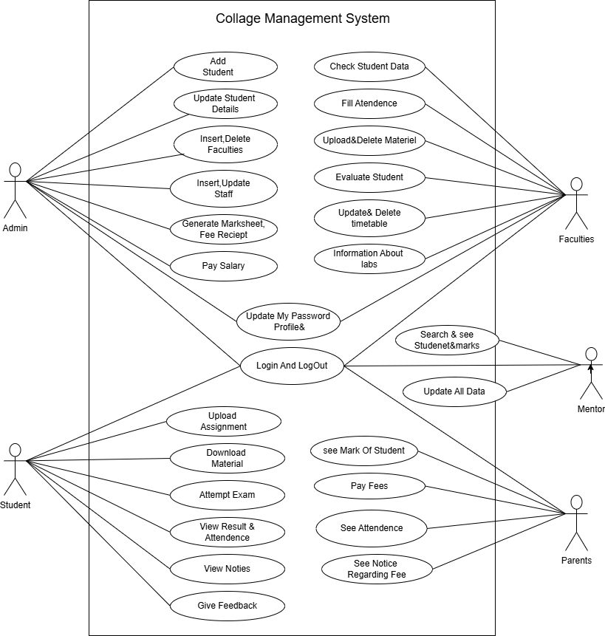

## Figure 2.1-1 Use case diagram for Collage management system

## Activity diagram and Swimlane diagram for Admin Activity

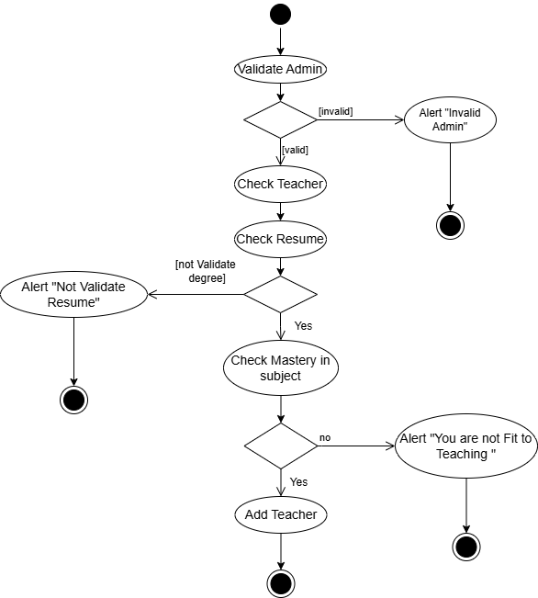

*Figure 2.2-1 Activity diagram for Admin Activity*

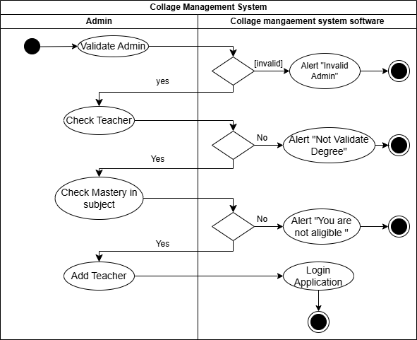

*Figure 2.2-2 Swimlane diagram for Admin Activity*

## Activity diagram and Swimlane diagram for Student Activity

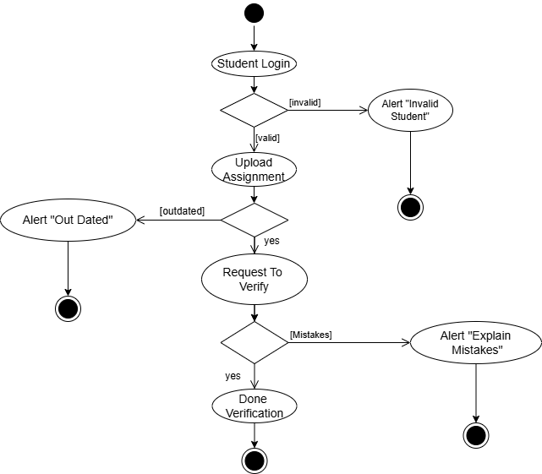

*Figure 2.2-3 Activity diagram for Student Activity*

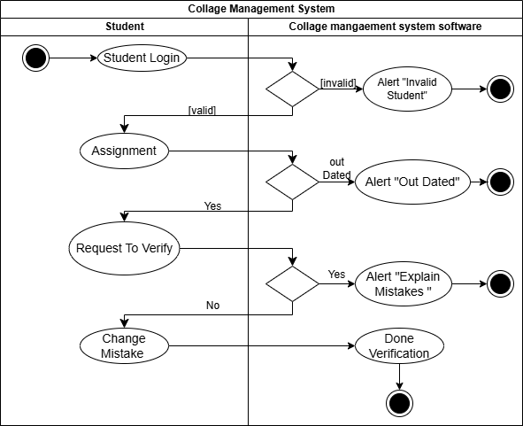

*Figure 2.2-4 Swimlane diagram for Student Activity*

## Sequence diagram

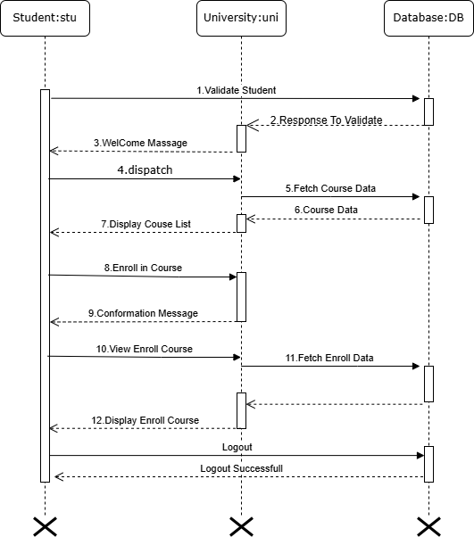

*Figure 2.3-1 Sequence diagram for Student course*

*Figure 2.3-2 Sequence diagram for Admin Task*

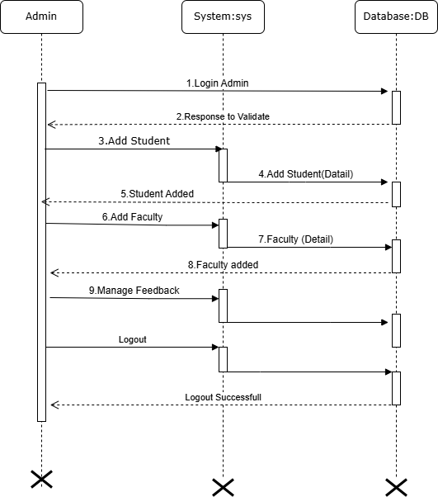

## State diagram

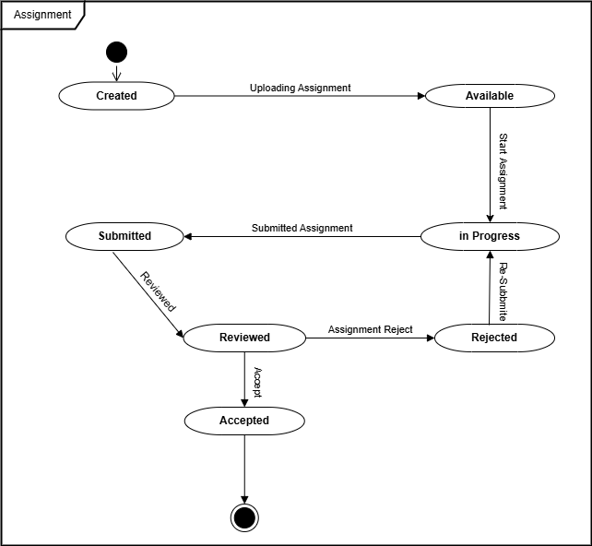

*Figure 2.4-1 State diagram of Assignment*

## Class diagram

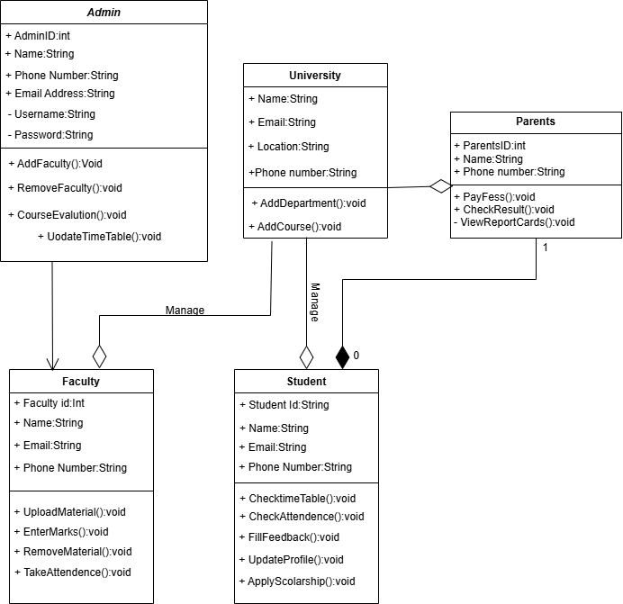

*Figure 2.5-1 Class diagram for collage management system*

## Data flow diagram

### Context diagram (level-0)

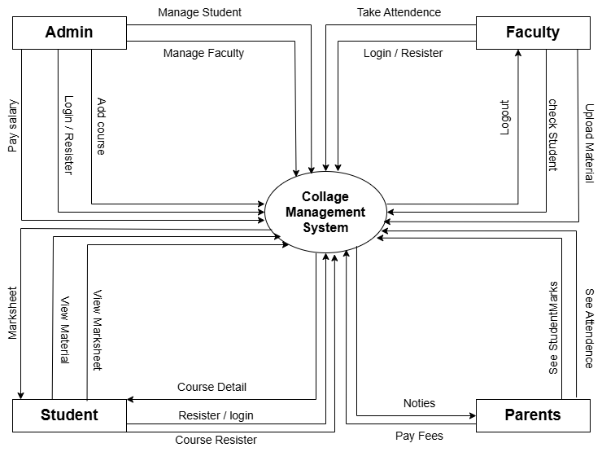

*Figure 2.6-1 Context diagram for Collage management system*

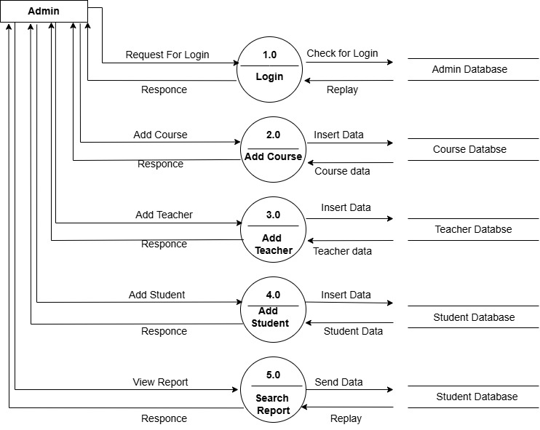

*Figure 2.6-2 DFD level-1 for collage management system*

Admin

### DFD Level-2

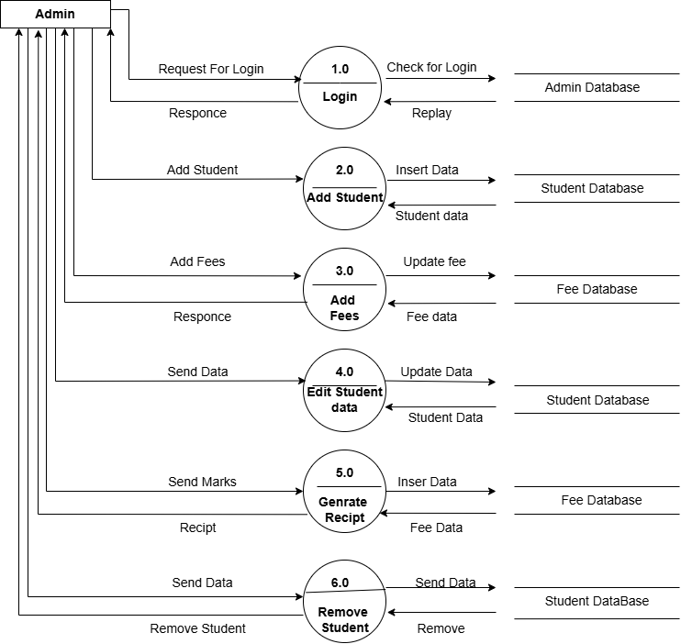

*Figure 2.6-3 DFD level-2 for Admin*

# External interface requirement (Screens)

## Screen-1: Registration Form

*Figure 3.1-1 Screen-1: Registration Form*

**Purpose:** This form will allow the target end-users to register in the system. To register , the following information will be encoded in the system.

*Table 3.1-1 Screen element of Registration form*

|  |  |  |  |  |  |
| --- | --- | --- | --- | --- | --- |
| **Sr.** | **Screen Element** | **Input Type** | **O/M** | **1/N** | **Description** |
| **1** | Username | Textbox | M | 1 | Username field should be editable and accept  the Username. |
| **2** | Email | Textbox | M | 1 | Email field should be editable and accept the  email with proper format. |
| **3** | Password | Password | M | 1 | Password field should be editable and accept the  password and display as star or dot. |
| **4** | Retype  password | Password | M | 1 | Retype Password field should be editable and  accept the password and display as star or dot. |
| **5** | I agree to the  terms | Checkbox | M | 1 | Checkbox for accepting terms and condition. |
| **6** | I already have a  membership | Link | ------ | ------ | Link for navigate to login page for registered  user. |
| **7** | Register | Button | ------ | ------ | Register is a button for store the entered data  into database. |

## Screen-2: Login Form

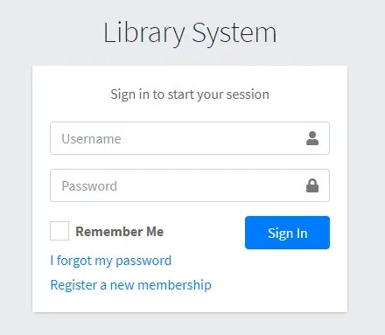

*Figure 3.2-1 Screen-2: Login Form*

**Purpose:** This form will be used by the system’s users to access records and features of the system. The users

will input the correct combination of their username and password to be able to login to the system.

*Table 3.2-1 Screen element of Login form*

|  |  |  |  |  |  |
| --- | --- | --- | --- | --- | --- |
| **Sr.** | **Screen Element** | **Input Type** | **O/M** | **1/N** | **Description** |
| **1** | Username | Textbox | M | 1 | Username field should be editable and accept  the Username. |
| **2** | Password | Password | M | 1 | Password field should be editable and accept the  password and display as star or dot. |
| **3** | Remember Me | Checkbox | M | 1 | Saving login credentials through remember me  checkbox |
| **4** | I forgot my  password | Link | ------ | ------ | Link for navigate to Forgot password page for  allows users to recover password. |
| **5** | Register a new  membership | Link | ------ | ------ | Link for navigate to membership registration. |
| **6** | Sign in | Button | ------ | ------ | Login button navigates to another page even if  valid login credentials. |

## Screen-3: Add borrower book

*Figure 3.3-1 Screen-3: Add borrower book*

**Purpose:** This module will allow the system administrator to add, edit, update or delete borrowers of book. The admin can add borrower information and manage it.

*Table 3.3-1 Screen element of Add borrower book*

|  |  |  |  |  |  |
| --- | --- | --- | --- | --- | --- |
| **Sr.** | **Screen Element** | **Input Type** | **O/M** | **1/N** | **Description** |
| **1** | Borrower ID | Textbox | M | 1 | Borrower ID field should be editable and fill autogenerated Borrower ID. |
| **2** | Student ID | Textbox | M | 1 | Student ID field should be editable and accept  Student barcode id. |
| **3** | First Name | Textbox | M | 1 | First Name field should be editable and accept  only string as a borrower first name. |
| **4** | Middle Name | Textbox | O | 1 | Middle Name field should be editable and accept  only string as a borrower middle name. |
| **5** | Last Name | Textbox | M | 1 | Last Name field should be editable and accept  only string as a borrower last name. |
| **6** | Contact | Textbox | M | 1 | Contact field should be editable and accept only  10-digit mobile number. |
| **7** | Grade Id | Textbox | O | 1 | Auto fetch detail from the database if proper  student id is entered. |
| **8** | Submit | Button | ----- | ----- | Submit is a button for store the entered data into  database. |
| **9** | Cancel | Button | ----- | ----- | Cancel is a button for close add borrower dialog. |

# Database design

## List of Tables

* Book
* Borrower
* Student
* Staff

*Table 4.1-1 Table: Book*

|  |  |  |  |  |
| --- | --- | --- | --- | --- |
| **Column** | **Data Type** | **Null** | **Keys & Constrains** | **Default Value & Description** |
| **BookID** | int | NN | PK (Auto Increment) |  |
| **BookName** | varchar(100) | NN |  |  |
| **ISBN** | varchar(100) | AN |  |  |
| **Publication_year** | int | AN |  |  |
| **Language** | varchar(50) | AN |  |  |

*Table 4.1-2 Table: Borrower*

|  |  |  |  |  |
| --- | --- | --- | --- | --- |
| **Column** | **Data Type** | **Null** | **Keys & Constrains** | **Default Value & Description** |
| **BorrowerID** | int | NN | PK (Auto Increment) |  |
| **BookID** | varchar(100) | NN | FK | Reference of Book Table |
| **BorrowedFromDate** | DateTime | AN |  |  |
| **BorrowedToDate** | DateTime | AN |  |  |
| **ActualReturnDate** | DateTime | AN |  |  |
| **IssuedBy** | int | NN | FK | Reference of Student and  Staff Table |

*Table 4.1-3 Table: Staff*

|  |  |  |  |  |
| --- | --- | --- | --- | --- |
| **Column** | **Data Type** | **Null** | **Keys & Constrains** | **Default Value & Description** |
| **StaffID** | int | NN | PK (Auto Increment) |  |
| **StaffName** | varchar(100) | AN |  |  |
| **IsAdmin** | Boolean | AN |  |  |
| **Designation** | varchar(100) | AN |  |  |

*Table 4.1-4 Table: Student*

|  |  |  |  |  |
| --- | --- | --- | --- | --- |
| **Column** | **Data Type** | **Null** | **Keys & Constrains** | **Default Value & Description** |
| **StudentID** | int | NN | PK (Auto Increment) |  |
| **StudentName** | varchar(100) | AN |  |  |
| **Gender** | varchar(100) | AN |  |  |
| **DOB** | DateTime | AN |  |  |
| **Department** | varchar(100) | AN |  |  |
| **Contact** | number(10,0) | AN |  |  |

# Stories and Scenario

## Story-1: Add New Book in Library Catalogue

|  |  |  |
| --- | --- | --- |
| *Story #* ***S1*** | **:** | **As a** Librarian,  **I want to** add a new book in library catalogue  **So that** everyone can easily find and borrow it. |
| **Priority** | **:** | High |
| **Estimate** | **:** | XL |
| **Reason** | **:** | The addition of a new book to the library catalogue is crucial for ensuring that  the library's collection is up-to-date and accessible to everyone. |

### Scenario# S1.1

|  |  |  |
| --- | --- | --- |
| *Scenario#* ***S1.1*** | **:** | Adding a New Book with Valid Information |
| **Prerequisite** | **:** | Librarian is logged in to the Library management system. |
| **Acceptance Criteria** | **:** | **Given:** The Librarian is navigated to the library catalog management page. Valid book information, including title, author, ISBN, and other relevant details is added.  **When:**  The librarian selects the "Add New Book" option And The librarian enters valid book details  The librarian clicks the "Save" button to add the book to the catalog.  **Then t**he system successfully adds the book to the catalog and the librarian receives a confirmation message with the book's identification number. |

* + 1. Scenario# S1.2

|  |  |  |
| --- | --- | --- |
| *Scenario#* ***S1.2*** | **:** | Adding a New Book with Invalid Information. |
| **Prerequisite** | **:** | The librarian is logged into the library management system. |
| **Acceptance Criteria** | **:** | **Given:** The librarian is on the library catalogue management page  **When:** The librarian selects the "Add New Book" option and the librarian enters an incomplete or incorrect book details and librarian clicks the "Save" button to add the book to the catalogue.  **Then t**he system displays error messages for the incorrect or missing information and the book is not added to the catalogue. |

* + 1. Scenario# S1.3

|  |  |  |
| --- | --- | --- |
| *Scenario#* ***S1.3*** | **:** | Attempting to Add a Duplicate Book |
| **Prerequisite** | **:** | The librarian is logged into the library management system and the  librarian is on the library catalogue management page |
| **Acceptance Criteria** | **:** | **Given**: The book information, including title, author, ISBN, and other relevant details, is available and the book with the same ISBN is already in the catalogue.  **When**: User Clicks on “Add book” button. Enter a number of copies with  the same book detail mentioned in the field. |

**Then**: Generate unique book id, barcode and spine label for various book of same title.

## Story-2: Search Book

|  |  |  |
| --- | --- | --- |
| *Story #* ***S2*** | : | **As a** Librarian or member,  **I want to** search for books by title, author, or keyword,  **So that** I can quickly find books that match my interests. |
| **Priority** | **:** | High |
| **Estimate** | **:** | M |
| **Reason** | **:** | Implementing a search functionality is essential for enhancing the user  experience, as it allows librarian and member to efficiently discover and access the library's resources. |

* 1. **Story-3: Manage due date for borrowed book**

|  |  |  |
| --- | --- | --- |
| *Story #* ***S3*** | **:** | **As** Librarian,  **I want** to manage due dates for borrowed books  **So that** I can ensure that books are returned on time and avoid overdue fines. |
| **Priority** | **:** | High |
| **Estimate** | **:** | M |
| **Reason** | **:** | Proper due date management is crucial for maintaining the library's collection  and ensuring that books are available for all members. |

## Story-4: Renew book

|  |  |  |
| --- | --- | --- |
| *Story #* ***S3*** | **:** | **As** Librarian,  **I want** to renew a book that I have borrowed  **So that** I can extend my borrowing period if needed. |
| **Priority** | **:** | Medium |
| **Estimate** | **:** | M |
| **Reason** | **:** | Book renewal functionality is a convenience feature for librarian, allowing  them to keep a book for an extended period if no one else has requested it. |

* 1. **Story-5: Generate a report on book usage and availability**

|  |  |  |
| --- | --- | --- |
| *Story #* ***S3*** | **:** | **As** Librarian,  **I want** to generate reports on library usage and book availability  **So that** I can make informed decisions about library’s books. |
| **Priority** | **:** | Medium |
| **Estimate** | **:** | L |
| **Reason** | **:** | Reporting functionality helps librarians track the usage of library resources and  make data-driven decisions to improve services and collections. |

# Test cases

|  |  |  |  |
| --- | --- | --- | --- |
| **Project Name:** | **EMI Calculator** | **Test Designed by:** | **P. U. Jadeja** |
| **Module Name:** | **Login** | **Test Designed date:** | 01-10-2023 |
| **Release Version:** | **1.0** | **Test Executed by:** | **R. B. Gondaliya** |
|  |  | **Test Execution date:** | 15-01-2023 |

|  |  |  |  |  |
| --- | --- | --- | --- | --- |
| **Pre-condition**: **Web application should be accessible** | | | | |
| **Test Case ID** | **Test Title** | **Test Type** | **Description** | **Test Case ID** |
| **TC_001** | Login to web application with valid  credential | Functional | Login to Library management system web application through  valid credential | TC_001 |
| **TC_002** | Login to web  application with  invalid credential | Functional | Login to Library management system web application through  invalid credential | TC_002 |
| **TC_003** | Varify login page  elements | GUI | varify that all elements are availabe  on login page | TC_003 |

|  |  |
| --- | --- |
| Test Case Title | Login to web application with valid credential |
| Test Type | Functional |
| Test Priority | High |
| Pre-condition | Web application should be accessible |

|  |  |  |  |  |  |  |  |
| --- | --- | --- | --- | --- | --- | --- | --- |
| Test  Step | Test Case  Description | Expected Result | Actual Result | Status | Comment | Data | BUG ID |
| 1 | Access Web  application URL | The site  launched properly | Site launched successfully | Pass |  | [https://accounts.](https://accounts.google.com/ServiceLogin) [google.com/Ser](https://accounts.google.com/ServiceLogin) [viceLogin](https://accounts.google.com/ServiceLogin) |  |
| 2 | Enter valid Username in username field | Username field should be  editable and  accept the Username | Username input accepted | Pass |  | Username: Rbgondaliya@ gmail.com |  |
| 3 | Enter valid Password in Password field | Password field should be  editable and  accept the password and display as star or dot | Password input displayed in dot and accepted | pass |  | Password: rbgondaliya |  |
| 4 | Enter valid captcha code in captch field | Captch field should editable and accept captcha and captcha is case sensitive | Captcha input accepted | Pass | Step require d when human action validati  on | get captcha  from image which is near by captcha field |  |

|  |  |  |  |  |  |  |  |
| --- | --- | --- | --- | --- | --- | --- | --- |
|  |  |  |  |  | perfor m |  |  |
| 5 | Click on login button | User should login into site and navigated to dashboard | User navigated to dashboard and username should br display in top of the right  side. | pass |  |  |  |

|  |  |
| --- | --- |
| Test Case Title | Login to web application with invalid credential |
| Test Type | Functional |
| Test Priority | Medium |
| Pre-condition | Web application should be accessible |

|  |  |  |  |  |  |  |  |
| --- | --- | --- | --- | --- | --- | --- | --- |
| Test Step | Test Case Description | Expected Result | Actual Result | Status | Comment | Data | Bug ID |
| 1 | Verify that User is not able to Login with invalid Username and invalid  Password | Should be display an error message enter wrong username or password | Display an  error of wrong username and password | Pass |  |  |  |
| 2 | Verify that User is not able to Login with Valid Username and invalid  Password | Should be display an error message enter wrong password | Display an  error of wrong password | Pass |  |  |  |
| 3 | Verify that User is not able  to Login with | Should be display an error message | Display an error Username not found | Pass |  |  |  |

|  |  |  |  |  |  |  |  |
| --- | --- | --- | --- | --- | --- | --- | --- |
|  | invalid Username and Valid  Password | User not found |  |  |  |  |  |
| 4 | Verify that User is not able to Login with blank Username or  Password | Set required field validation message for Username and  Password | Display an  error of wrong username and password | Fail | Not performa a validation function fix it |  | Bug_002 |

|  |  |
| --- | --- |
| Test Case Title | Varify login page elements |
| Test Type | GUI |
| Test Priority | Medium |
| Pre-condition | Web application should be accessible |

|  |  |  |  |  |  |  |  |
| --- | --- | --- | --- | --- | --- | --- | --- |
| Test Step | Test Case Description | Expected Result | Actual Result | Status | Comment | Data | Bug ID |
| 1 | Launch application with the  given url | The site launched properly | Site launched successfully | Pass |  | [https://accounts.googl](https://accounts.google.com/ServiceLogin) [e.com/ServiceLogin](https://accounts.google.com/ServiceLogin) |  |
| 2 | Verify that the login screen contains elements such as Username, Password, Sign in button, Remember password check box, Forgot password link, and Create an account  link. | All listed control displayed properly on the page | Login page loaded successfully | Pass |  |  |  |

|  |  |  |  |  |  |  |  |
| --- | --- | --- | --- | --- | --- | --- | --- |
| 3 | Verify that cursor is focused on “Usernam e” text box on the  page load | Cursor is focused in Usernam e textbox | Cursor focus in Username textbox | Pass |  |  |  |
| 4 | Verify that tab functionali ty is  working properly or not | When tab pressed cursor move in next control | Cursor moving in next control | Pass |  |  |  |
| 5 | Verify that all the fields such as Username, Password has a valid  placeholde r | All text fields have proper placehold er | All text fields have proper placeholder | Pass |  |  |  |
| 6 | Verify that the labels float upward when the text field is in focus or filled (In  case of floating label) | When field is focused or filled, label display on top of the filled | When field is focus or filled, label display on top of the filled | Pass | step required when fields with floating label |  |  |
| 7 | verify that forgot password link working properly | when click on forgot password load forgot passworg  page | forgot password link not working | Fail |  |  |  |

1. **References**

* <http://www.w3schools.com/html/html_intro.asp>
* https://[www.w3schools.com/php/default.asp](http://www.w3schools.com/php/default.asp)
* https://[www.javatpoint.com/uml](http://www.javatpoint.com/uml)